Ticker Timers
Ticker timers are small machines that mark dots on a piece of paper. They produce 50 dots every second. They have a small pin that vibrates up and down making the dots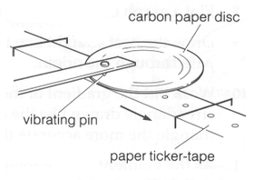
A strip of paper is pulled through the ticker timer. If the strip of paper is pulled through the timer slowly the dots will be close together. If the strip is pulled through the timer quickly the dots will be far apart.
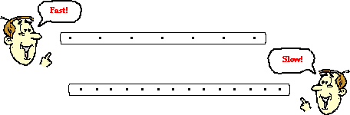
Try it and stick your results into the spaces below.
Ticker tape pulled fast | Ticker tape pulled slowly

Acceleration and Ticker Timers
Acceleration=the rate that an objects speed increases.
Now try this. Pull the paper through slowly at first and then faster. You are increasing the speed of movement of the paper. You are accelerating the paper through the ticker timer.
Stick the paper strip in this box and write a description of what happens to the dots.
Stick paper strip here | What is happening to the dots?

